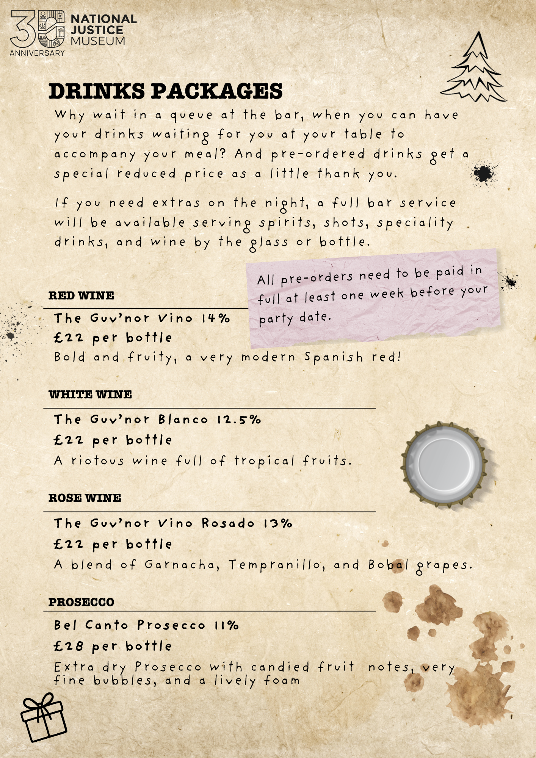

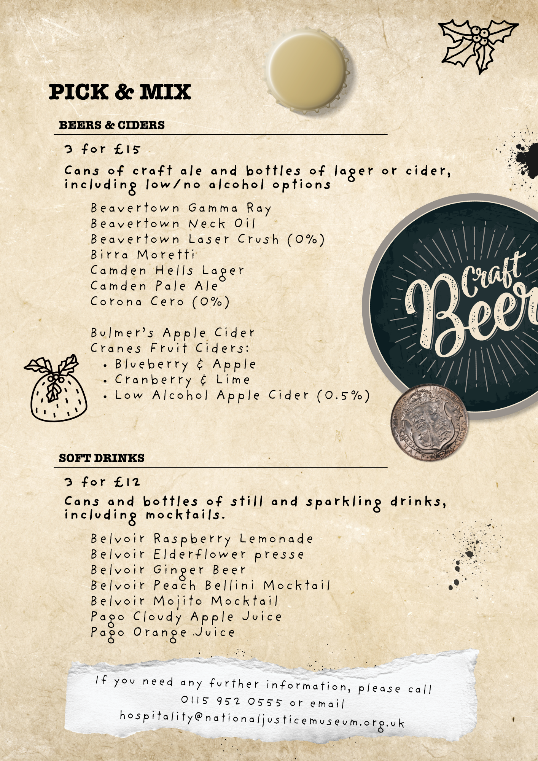



Booker's name |  | Company name  (if applicable)
Order number |  | Party date

Item | Price | Quantity | Cost
The Guv’nor Vino (Red wine, bottle) | £ 22.00 |  | £
The Guv’nor Blanco (White wine, bottle) | £ 22.00 |  | £
The Guv’nor Vino Rosado (Rose wine, bottle) | £ 22.00 |  | £
Bel Canto Prosecco (Bottle) | £ 28.00 |  | £
Beer & Cider Pick & Mix (3 items) | £ 15.00 |  | £
Beavertown Gamma Ray |  |  | --
Beavertown Neck Oil |  |  | --
Beavertown Laser Crush (0%) |  |  | --
Birra Moretti |  |  | --
Camden Hells Lager |  |  | --
Camden Pale Ale |  |  | --
Corona Cero (0%)
Bulmer’s Apple Cider |  |  | --
Cranes Blueberry & Apple Cider |  |  | --
Cranes Cranberry & Lime Cider |  |  | --
Cranes Low Alcohol Apple Cider (0.5%)
Soft Drink Pick & Mix (3 items) | £ 12.00 |  | £
Belvoir Raspberry Lemonade |  |  | --
Belvoir Elderflower presse
Belvoir Ginger Beer |  |  | --
Belvoir Peach Bellini Mocktail |  |  | --
Belvoir Mojito Mocktail |  |  | --
Pago Cloudy Apple Juice |  |  | --
Pago Orange Juice |  |  | --
Grand Total |  |  | £

